Practical Manual
B. Sc. (Hons.) Agriculture
Introduction to Forestry
Course Code: ASIF1201
Course Credits: (1+1)
Semester: 2nd
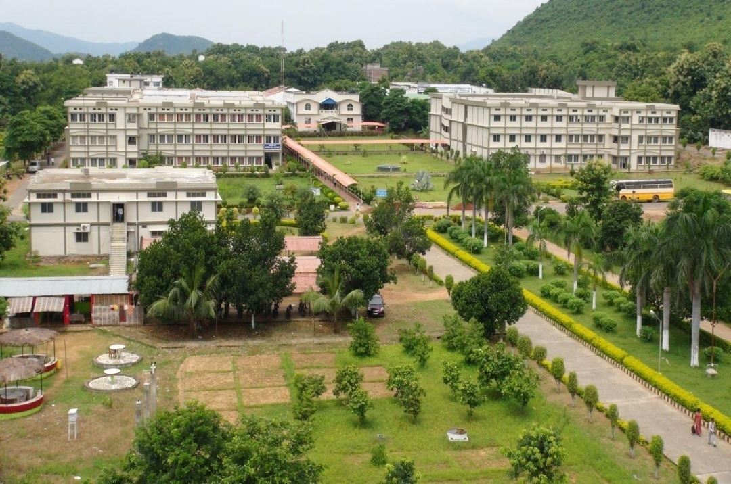

Department of Agronomy and Agroforestry
M. S. Swaminathan School of Agriculture
Centurion University of Technology and Management, Paralakhemundi
www.cutm.ac.in
Dec, 2019
Practical Manual
B. Sc. (Hons.) Agriculture
Introduction to Forestry
Course Code: ASIF1201
Course Credits: (1+1)
Semester: 2nd

Department of Agronomy and Agroforestry
M. S. Swaminathan School of Agriculture
Centurion University of Technology and Management, Paralakhemundi
www.cutm.ac.in
Dec, 2019

Department of Agronomy and Agroforestry
M. S. Swaminathan School of Agriculture
Centurion University of Technology and Management
Paralakhemundi

Certificate

Certified that this is a bonafide record of practical work done by Mr./ Ms. ________________________________________________Regd. No.___________________ _______________________ in B. Sc. (Hons.) Agriculture degree programme, Course No. ASIF1201 entitled “Practical of Introduction to Forestry” during 2nd semester of the academic year 2019-20.

Date: Faculty–in-Charge

Evaluation System
Practical Introduction to forestry
Course Code: ASIF1201

Sl. No. | Marks distribution* | Total marks | Marks obtained
1 | Record | 05
2 | Attendance | 05
3 | Field performance | 10
4 | Assignment | 05
Total (25 marks)

Signature of Faculty in-Charge

List of Experiments
Exp. No. | Date of Exp. | Date of Submission | Title | Page No. | Signature | Remark
1 |  |  | Practical Identification of tree-species(1)
2 |  |  | Practical Identification of tree-species(2)
3 |  |  | Diameter measurements using calipers and tape
4 |  |  | Height measurement of standing trees by shadow method, single pole method
5 |  |  | Height measurement of standing trees by Instrumental method
6 |  |  | Volume measurement of logs using various formulae.
7 |  |  | Nursery lay out and seed sowing
8 |  |  | Sowing methods of small, medium and large size seeds in nursery
9 |  |  | Vegetative propagation techniques
10 |  |  | Forest plantations and their management
11 |  |  | Visits to nearby Forest based industries(1)
12 |  |  | Visits to nearby Forest based industries(2)

Experiment No. 1 Date------------
Practical Identification of tree-species (1)
1.1 Aim
To identity the trees and shrubs in and around university campus.
1.2 Observation
To know different plant species in and around campus and their importance
1. Acacia auriculiformis
Family: __________________________
Englishname: ________________________

Description:

Uses:

2. Acacia mangium
Family: ___________________
Englishname:__________________

Description:

Uses:

3. Acacia nilotica
Family: ___________________
Englishname: _____________________
Description:

Uses:

4. Adenanthera pavonina
Family: ___________________
Englishname: ___________________
Description:

Uses:

5.Adina cordifolia
Family: ____________________
Englishname: ____________________
Description:

Uses:

6. Aegle marmelos
Family: ___________________
English name: ___________________
Description:

Uses:

7.Ailanthus excelsa
Family: ________________
Englishname: _________________
Description:

Uses:

8. Albizia lebbek
Family: _____________________
Englishname: ____________________
Description:

Uses:

9.Albizia procera
Family: ___________________
Englishname: ___________________
Description:

Uses:

10.Anogeissus acuminata
Family: _________________
English name: ____________________

Description:

Uses:

11.Anthocephalus cadamba, Neolamarckia cadamba
Family: _________________
Englishname: __________________
Description:

Uses:

12.Artocarpus heterophyllus
Family: ________________
Englishname: __________________
Description:

Uses:

13.Azadirachta indica
Family: ________________
English name: __________________
Description:

Uses:

14.Bambusa bamboo
Family: __________________
English name: __________________
Description:

Uses:

15.Thyrostachys oliveri
Family: _________________
Description:

Uses:

16. Bambusa striata
Family:_________________
English name: _______________
Description:

Uses:

17.Bambusa vulgaris
Family: _______________
English name: ___________________
Description:

Uses:

18. Bauhinia variegata
Family: __________________
English name: ___________________
Description:

Uses:

19.Bixa orellana
Family: ________________
English name: ___________________
Description:

Uses:

20.Bridelia retusa
Family: _________________
English name: _________________
Description:

Uses:

21.Calophyllum inophyllum
Family : ___________________
English name: _________________
Dscription:

Uses:

22.Caryota urens
Family: ________________
English name: _________________
Description:

Uses:

23.Cassia fistula
Family: _________________
English name: ___________________
Description:

Uses:

24.Cassia siamea
Family: _______________
English name: _________________
Description:

Uses:

25.Casuarina equisetifolia
Family: ___________________
English name:_________________
Description:

Uses:

1.3 Conclusion

Signature of Faculty in-Charge
Experiment No. 2 Date------------
Practical Identification of tree species (Part-II)

2.1 Aim
To identity the trees and shrubs in and around university campus.
2.2 Observation
To know different plant species in and around campus and their importance.
26.Ceiba pentandra
Family: _________________
Englishname:_________________
Description:

Uses:

27.Cinnamomum tamala
Family: __________________
English name: ___________________
Description:

Uses:

28. Cinnamomum zeylanicum
Family: ____________________
English name: _________________
Description:

Uses:

29.Dalbergia sissoo
Family: _________________
Englishname:_________________
Description:

Uses:

30.Delonix regia
Family: ________________
Englishname:_________________
Description:

Uses:

31.Dendrocalamus strictus
Family: ____________________
Englishname:_________________
Description:

Uses:

32.Diospyros melanoxylon
Family: ___________________
Englishname:_________________
Description:

Uses:

33. Emblica officinalis

Family: ___________________
Englishname:_________________

Description:

Uses:

34.Eucalyptus tereticornis

Family: ________________
Englishname:___________________
Description:

Uses:

35.Gliricidia sepium

Family: ___________________
Englishname:___________________

Description:

Uses:

36. Gmelina arborea
Family: ____________________
English name:_________________
Description:

Uses:

37. Hevea brasiliensis
Family: _________________
Englishname:_________________
Description:

Uses:

38. Inga dulcis
Family: __________________
English name:_________________
Description:

Uses:

39. Largerstomia parviflora
Family: ______________________
English name:_____________________
Description:

Uses:

40. Lannea coromandelica
Family: _______________________
English name:_______________________
Description:

Uses:

41.Lawsonia inermis
Family: __________________________
Englishname:_______________________
Description:

Uses:

42.Laucaena leucocephala
Family: ________________________
Englishname:_________________
Description:

Uses:

43.Madhuca indica
Family: ________________________
Englishname:_________________
Description:

Uses:

44. Melia azedarach
Family: ___________________
Englishname:_______________________
Description:

Uses:

45.Mimusops elengi
Family: ______________________
English name:_________________
Description:

Uses:

2.3Conclusion

Signature of Faculty in-Charge

Experiment No. 3 Date------------
Diameter and girth measurement over bark and under bark of normal and abnormal trees
3.1 Aim:
To measure the DBH and GBH (Over and under bark) of normal and abnormal trees.
3.2 Objective:
To estimate the growth of normal and abnormal trees.
3.3 Materials required:
- Caliper
- Tape
- Swedish bark gauge
- Stick of 1.37m length
- Chalk/geru/paint
3.4 Procedure:
- Procedure for measurement of DBH over bark-
DBH (OB) is measured generally by calliper. In order to use the caliper the fixed arm and the movable arm of calliper are held with two hands. The movable arm is opened and then calliper is fitted to the point of measurement. The movable arm is shifted back close to the bole and reading is recorded. While taking reading of three arms i.e. the main arm, fixed arm, movable arm should touch the bole of the tree. The main arm should be right angle to the bole or trunk of the tree. The DBH is recorded in cm. It is measured in two opposite sides one along the major axis and other along the minor axis and the average value of two diameters is calculated. The DBH is recorded at a standard height i.e. 1.37m from the ground level.
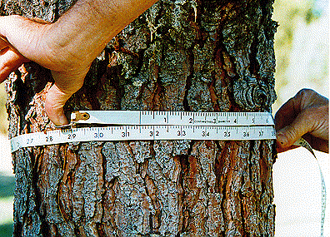
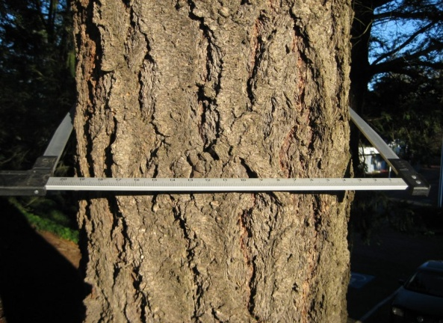

- Procedure for measurement of GBH over bark-
GBH is generally measured by a tape. For measuring GBH the tape is encircled at the point of measurement. The tape should be right angle to the main axis or bole of tree. It is recorded in meter.

3.5 Standard rules:

Rules of DBH measurement and instrument used

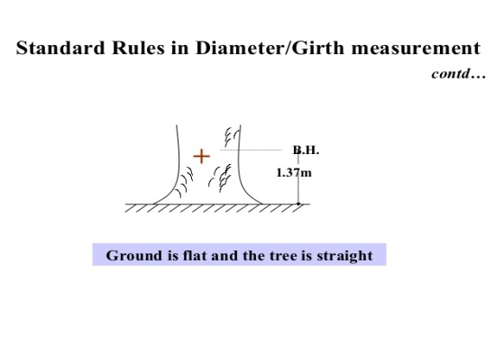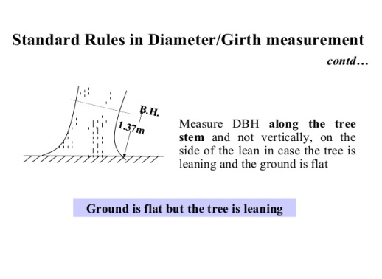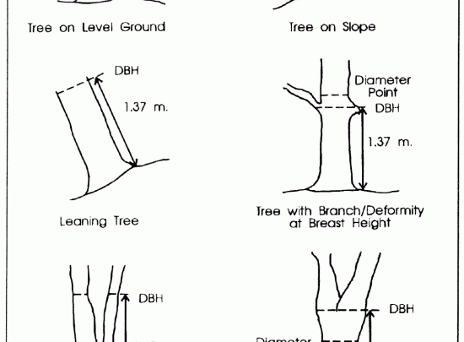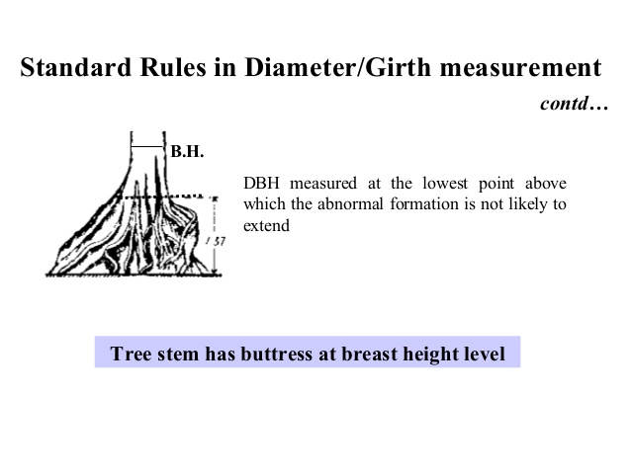
- Moss, creepers, lichens and loose bark found on the tree must be removed before measuring the dia. over bark.
- Breast height (BH) should be by means of a measuring stick on standing trees at 1.3m above the ground level.
- BH point should be marked by intersecting vertical and horizontal lines 12 cm long, painted with white paint.
- On sloping land, the diameter at BH should be measured on the uphill side.
- In case of the tree is leaning, dbh is measured along the tree stem and not vertically, on the side of the lean for trees growing on flat ground and on the uphill side, for trees growing on sloping ground.
- The dbh should not be measured at 1.3m if the stem is abnormal at the level. BH mark should be shifted up or down as little as possible to a more normal position of the stem and then dia. Measured.
- BH should be taken at the lowest point above which the buttress formation is not likely to extend
- When the tree is forked above the BH, it is counted as one tree, but when it is forked below BH, each fork should be treated as though it were a separate tree.

3.6 Observation to be recorded:
S. No | Name of the tree  Species | DBH of tree over bark(cm) |  |  | GBH of trees over bark(m) | Remarks
 |  | Major axis/Minor axis |  | Average
1
2
3
4
5

3.7 Procedure for measurement of DBH and GBH under bark:
The DBH over bark and GBH over bark are first determined following the standard procedure of diameter and girth measurement respectively. From this the diameter under bark and girth under bark are calculated as per following formulae:
Diameter under Bark (DUB) = Diameter Over Bark (DOB)-2t
Girth under Bark (GUB) = Girth Over Bark (GOB)-2πt
Where, t= bark thickness
The bark thickness is determined by Swedish bark gauge. Swedish bark gauge is an instrument in the form of a chisel which is pushed into the bark. Place the chisel end of the gauge against the bark and apply pressure to the handle until the chisel penetrates to the wood interface. The operator musty "feel" the change in pressure as the he / she attempts to push the chisel through the wood. Once the wood has been reached, push the flange against the bark and read the thickness the scale. Considerable experience is needed to ensure the chisel reaches the interface but is not pushed too far through the wood.
Some points on procedure:
- Avoid twisting the gauge when it is embedded in the tree - the chisel tip is easily fractured.
- For trees with rough and fissured barks, measure bark thickness on the ridges.
- Ensure the flange of the gauge is flush with the bark before reading.
- If calipers are used for measuring diameter, measure bark thickness at the points of calliper.
- Because bark thickness tends to vary from one side of a tree to another, take 3-4 readings around the stem and average.
3.8 Observation to be recorded:
SI. No | Name of the species | Bark thickness(t) | DOB(cm) | DUB(cm) | GOB(m) | GUM(m)
1
2
3
4
5

3.9 Conclusion

Signature of Faculty in-charge

Experiment No. 4 Date------------
Height measurement of trees by shadow method and single pole method
4.1 Aim:
To measure the height measurement of trees by Single pole method and shadow method.
4.2 Objective:
To measure the height of trees by shadow non instrumental method.
4.3 Materials required:
- A pole of 2-3m length for shadow method
- A pole /scale of 1-1.5m length for single pole method
- A measuring tape.
A. Procedure for shadow method:
This method is applied for vertical trees. In this method, a pole of convenient length (2-3m) is fixed upright in the ground and its height above the ground is measured. The height of the tree can be calculated:
Height of the tree Shadow length of tree
Pole length above ground Shadow length of pole

Height of the tree Shadow length of the tree× Pole length above the ground
Shadow length of the pole

4.4 Observation to be recorded:
SI. No | Name of the tree | Pole length above ground(m) | Shadow length of the tree(m) | Shadow length of the tree(m) | Height of the tree(m)
1
2
3
4
5

B. Procedure for single pole method:
This method is applied for vertical trees. In this method, the observer holds a pole or scale of about 1-1.5m length vertically at arm's length in one hand in such a way that the portion of the pole above hand is equal in length to the distance of the pole from the eye. Without changing the position of hand with reference to the eye, the observer moves slowly forward and backward till the line of sight to the tip of tree passes through the tip of the pole and that to the base of tree through the point where the pole is held by hand. This means that the portion of the pole above the hand covers the tree completely. The height of the tree is then equal to the distance of the observers eye from the tree as per the principle of similar triangle.
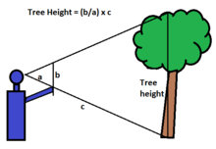

4.5 Observation to be recorded:

SI. No | Name of the tree | Distance of observers eye from the tree base(m) | Height of the tree(m)
1
2
3
4
5

4.6 Conclusion

Signature of Faculty in-Charge

Experiment No.5 Date------
Height measurement of the tree by Abney's level and Ravi altimeter
5.1 Aim:
To study about the height measurement of the tree by Christen's hypsometer and Ravi altimeter.
5.2 Objective:
To determine the growth of trees.
5.3 Materials required:
- Abney's level
- Ravi altimeter/multimeter
- Measuring tape.
A. Height measurement by Abney's level:
In order to use the instrument, the observer first makes the instrument inclined and bubbles/spirit level has to be adjusted. Therefore, while sighting the top, the screw is rotated to bring the spirit level in a horizontal position. As the spirit level approaches the horizontal position the bubble appears on the edge of the mirror. The spirit level is continued to be moved slowly to the position when the bubble image is bisected by the line of horizontal wire. At this position, The angle of elevation to the top of tree on the circular arc to be read and similarly the angle of depression is also taken. And the height of tree determine by tangent method. In case the eye level of observer is in between the top and base of trees, the height derived from angle of elevation and height from angle of depression is added to get the total height of tree.
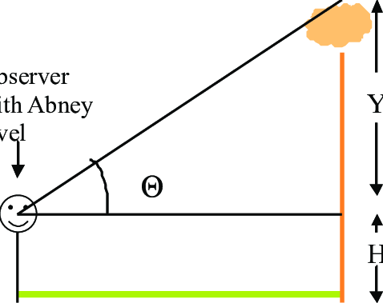

5.4 Observation to be recorded:
SI NO | Name of the tree Species | Slopping distance of observer from tree(m) | Horizontal distance of observer from tree(m) | Height reading of base with respect to eye(m) | Height reading of top with respect to eye(m) | Height of the tree(m) | Situation
1
2
3
4
5

A. Height measurement by Ravi altimeter/Multimeter:
The height of vertical trees is measured by this instrument. The tree whose height is to be measured should be accessible so that distance of the observer from tree can measured. First press the side level and see that pointer is moving freely. The tree is then viewed through eye piece and target in such that the target is in line with the top of the tree. Then gently press the front button to arrest the pointer. If the observation is made from a distance of 20m,then 20m scale (upper most) in read off. If the relevant distance is 30m, then 30m scale is read off. In order to get the total height of the tree, the eye height of the observer is added. If the observer distance is other then 20m or 30m, then the percentage scale (lowest scale) where readings are written in percentage is read off. Then the total height of the tree is calculated adding eye height of observer.

5.5 Draw Abney's level and Ravi altimeter instrument and labeled it.

5.6 Observation to be recorded:
SI No | Name of the tree species | Slopping distance of observer from tree(m) | Horizontal distance of observer from tree(m) | Height reading of base with respect to eye(m) | Height reading of top with respect to eye(m) | Height of the tree(m) | Situation
1
2
3
4
5

5.6 Conclusion

Signature of Faculty in-Charge

Experiment No. 6 Date-----------
Volume estimation of a tree
6.1 Aim :
To estimate the volume of felled trees.
6.2 Objective:
To estimate the content of wood in felled trees.
6.3 Materials required:
Calliper and Tape
6.4 Procedure:
The felled trees are first divided into logs. The length of logs depend upon the rate of taper and market requirement. As the diameter at the thin end of logs determines the sawn volume that can be taken out of it, the greater the length of taper the lesser is the length of log. But in certain case, higher rate for a longer timber is so profitable that longer length of logs are cut in spite of decrease in the converted volume. When logs are made for calculating volume , generally those are 3m length from base. After dividing the tree into different logs suitable formulae are applied depending on the shape of the logs for determination of volume of logs. Then volume of individual logs is added to get the volume of the particular felled tree.

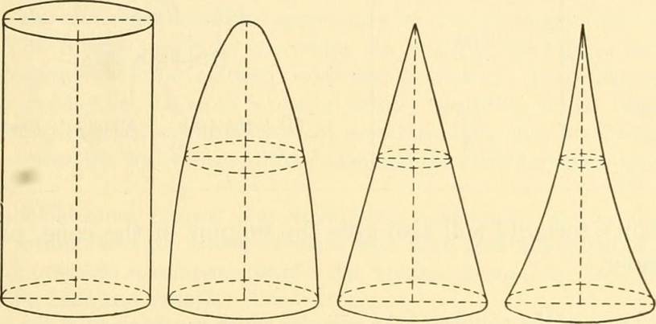
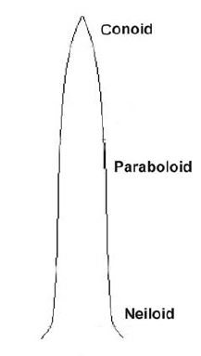

6.5 Write the different formula for calculation of volumes for different forms of solids

6.6 Observations to be recorded:

SI No | Name of the species | Log No | Volume of log | Formula applied
1
2
3
4
5

6.3 Conclusion

Signature of Faculty in-Charge

Experiment No. 7 Date------------
Forest nursery layout and preparation of nursery beds

7.1 Aim:
To study about forest nursery layout and preparation of nursery beds.

7.2 Objectives:
To raise forest nursery

7.3Materials required:
Land cleaning equipment, measuring tape, rope and soil working implements.

7.4 Nursery layout:
- Survey and demarcation :After the determination of the type and nature of a nursery the available land should be surveyed, mapping and demarcated so as to avoid any legal complications. After the survey, the area should be calculated and boundaries should be demarcated and permanent boundary, pillars should be constructed and area should be properly fenced according to the requirement game proof\ cattle proof\ deer proof etc. on the map the layout plan is drown-showing fence, nursery sheds, water supply, and arrangement of beds, roads, path and cross Paths, channel and main entrance etc.
- Clearance of site: All trees and bushes growth in the area should be felled. The stumps should be uprooted. The felled materials and the roots should be removed from the site. The big boulders and stones if any should also be removed along with the debris.
- Lay out and construction of terraces: Nursery layout will vary according to site. The type of plants to be raised the facilities to be provided and the topography of the site. In low hills and high hills the layout should be given across the slope i.e. along the contours. Height of the retaining wall to be constructed depends on the slope of the area.

7.5 Nursery construction:
As far as possible the nursery area is to be divided into a number of rectangular blocks separated by permanent paths or motorable roads 4 m. wide. Each block by constructing paths 1 m. wide and also smaller 0.6 m. wide between beds. Irrigation channel may be located in a way that they run along the permanent inspection paths, with the main water channel following the boundary of the nursery as shown in fig. In the nursery made for extensive mechanized plantations, there should be provision for wide roads on which tractors with trailers can play. Thus each nursery bed should have a tractor road on side of its length and on irrigation channel on the other. In the other words there should be a tractor road after every two beds so that polythene bag plants be loaded from the bed directly o the trailer without any difficult.The beds should be laid out with their length in east west direction. So, they can be shaded against frost and sun. Beds should be 1-1.2 m wide and the length of beds should be 5m, 10m, 15m, and/or according to land situation. The paths between beds should be 60 cm. wide as these are useful for inspection, weeding, irrigation and pricking out of seedlings etc. The water storage (overhead or below the ground) tank should be constructed inside the nursery near main tap or overhead tank should be established. The size of water storage tank depends upon the number of seedlings to be raised. A soil shed, small glass house/plastic house for seed germination under temperature and humidity control. Store house and office outside the nursery (or if possible inside the nursery). A drainage system may need to be prevent damage from heavy rains, this will be especially necessary on steeply sloping sites where drain should be constructed along the top edge and side of nursery. If drains have to be laid in slopping land, they should be formed in steps. That is they should be divided into short lengths of gentle gradient separated by almost vertical steps, faced with stone or brick masonry.

7.6 Draw the layout of a Forest Nursery

7.7 Types of Nursery beds & their preparation:

According to the moisture requirement of the species, beds can be of three type;
1. Raised beds:-
The seed beds which are prepared above the ground or path level is called raised bed in heavy moist area, which are liable to be water logged, raised beds may have to be prepared. Raised beds may have to be prepared 15 to 20 cm. above the ground level and where there is heavy moisture and the roots of seedlings require well drained soil and constructed by a line of bricks, stones or bamboos/split bamboos. This prevents their edges from being eroded away during the rainy season or by irrigation or outside water from seeping into the bed. The species which are commonly raised on beds are Deodar, Kail, Spruce, Fir, Robina, Walnut, Bird cherry.
Draw Raise Bed:

2. Sunken Beds:-
The seed beds which are prepared below the level of the ground or path are known as sunken beds. These types of beds are prepared in dry areas where scarcity of water for irrigation means water conservation is needed and is necessary to collect as much moisture as possible. For this purpose, the beds are made 10 to 15 cm. below the general ground level or the inspections paths. This type of beds are used are used for raising stock through vegetative propagation like cutting of popular, Sissoo, Mulberry, Willows, and Bamboos off sets. Besides these Acacia nilotica, A. benthenwii, Prosopis juliflora etc.
*Draw sunken Bed:

3. Level beds: - These are commonly used for raising seedlings of Tuni, Eucalyptus, Ritha, Terminalia, Siris, Grevillia etc. These species cannot tolerate standing water; their water requirement is also moderate.
*Draw Leveled Bed:

As According to the practice, beds can be of three types. They are;

1. Seedling beds:
A name given to beds in which the seeds germinate after sowing. The young seedlings remainin these beds for a short period of time after which they are usually picked out and transferred to transplant beds or standout beds.

2. Transplant Beds:
These are beds in which pricked out seedlings are raised after they have been transplanted from the seedlings beds. In transplant beds, the seedling are spaced out of more evenly, than compared to seedling beds in which the germinating seeds may or may not be so evenly spaced.

7.8 Conclusion

Signature of Faculty in-Charge

Experiment No. 8 Date------------
Sowing methods of small, medium and large size seeds in nursery

8.1 Aim:
To study about sowing methods of small, medium and large size seeds in nursery.

8.2 Objective:
To achieve higher plant percent.

8.3 Material required:
Seed of small, medium and large size species.

8.4 Procedure:
In nursery, seeds are sown in beds as well as in containers. The procedure for sowing small, medium and large size seeds are described below:
Sowing of small size seeds:
The small size seeds like Eucalyptus, Kadam, Haldu, etc. are mixed with earth or sand and then sown. The sowing of only seeds cause loss of seeds. These seeds are not generally sown directly in containers. These are first sown in seed beds and later on the seedlings are pricked out and transferred to containers. The small seeds are sown in beds either by broadcasting or in lines. Sowing of seeds in lines helps in better management. Seeds should not be sown too deep otherwise there is chance that seeds may not germinate. On the other hand, if seeds are sown too shallow, there is chance of loss of seed due to attack by ants, birds, etc. and by sun. The sowing depth should be 2.5 to 5.0mm. In light soils, seeds may be sown slightly deeper than heavy soils.
Sowing of medium size seeds:
On the other hand the seeds in which germination percent is less and germination process is not completed in short period are sown in beds. For example Teak, the species in which initial growth of plant is very rapid and plants cannot tolerate shock of transferring from seed bed to container. The medium size seeds are sown are sown either in container or in bed or in is carried out in main field, seeds are sown in bed, For example. Sissoo, Teak, Bamboo. While sowing the seeds in beds, this can be done by broadcasting, dibbling without mixing with any medium. The seeds both depending on the germination ability of the species and success rate of transplanting. The medium size seeds 1n germination percent is high and germination process are completed in short period (less than 2 weeks) are sown directly in container. For example, Acacia mangium, Acacia auriculiformis, Samanea saman, Albizia lebbek, etc. The species in which initial growth of plants is very rapid and the plants can't tolerate shock of transplanting and drilling method. Broadcasting does not give good seedlings The seeds to be sown in beds in lines by dibbling or by drill method. Broadcasting does not give good seedlings. The spacemen in sowing is adjusted according to the germination percent and size of plants required. The distance between lines should ordinarily be kept as 10em. Seeds should not be sown to dense because it will show poor germination, greater mortality, poor growth of seedlings and damping of The depth of medium size seeds is usually equal to the diameter of seeds.
Sowing of large size seeds:
The large size seeds are sown in beds and containers depending on their germination percent, period of germination, success rate in transferring plants germinant from bed to container, whether the plants to be used for naked root plating or stump Preparation. The seeds in which germination percent is high or period of germination is short or success of transferring plants / new germinant from bed to container is low are sown in container For example, Jamun, Calophylum, jackfruit Whereas the seeds in which germination percent is les or period of germination is long or success of transferring plants/ new germinant from bed to container is higher plants are raised for naked root planting / stump making are sown in beds. For example, Bijasal, Red sandal, Arjun, Terminalia chebula,etc. In beds, the seeds can be sown by broadcasting, dibbling and drilling. Sowing in lines gives better result. Though spacing depends on species and Size of planting materials to be generated, the usual practice is to sow seeds in spacing of 15cm x 10cm. The depth of sowing is equal to the diameter of seeds.

8.5. Sowing Methods of different tree seeds
Sl. No | Common Name | Scientific Name | Family | Seed Size | Method of Sowing

8.6 Conclusion

Signature of Faculty in-Charge

Experiment No. 9 Date-----------
Vegetative propagation technique of common Bamboo, Eucalyptus, Casuarina and Teak.

9.1 Aim:
To study about vegetative propagation technique of Common Bamboo, Eucalyptus, Casuarina and Teak.

9.2 Objective:
To generate clonal materials of commercial forest species like Common Bamboo, Eucalyptus, Casuarina and Teak.

9.3 Procedure:

1. Vegetative propagation technique of Common Bamboo: Bambusa vulgaris known as common bamboo is a commercial bamboo and propagated by vegetative method because it does not produce seed. It can be propagated vegetative by culm cutting, culm branch cutting, offset, rhizome and micro propagation method. For commercial propagation, plants propagated by culm cutting are generally used and the procedure of its propagation by culm cutting method is described here. One to two year old culms are selected from good mother clump. Those are extracted from the clump in the l month of March leaving basal two nodes. After removal from the mother clump, top 1/3" portion of culm which is thin is discarded. The branches are pruned leaving2 inches basal portion. The culm is divided into cuttings of one noded, two noded are used for easy handling. In case of two noded or higher noded cuttings, the culm cavity is opened at the cent of the inter-node, in such a way that the culm-branches would be horizontal to the ground. The cuttings are soaked in water for 24 hours. Then the cuttings are placed in nursery beds, which are earlier. The width of bed is 1m and depth is 15cm. One to two inch layer of ground FYM is applied in the bed and mixed with soil for better growth of the cuttings. The cuttings are placed parallel t a distance of 30-40cm from one another. Water is filled up in the culm cavity through the opening hole (2cm x lcm size) in case of cuttings having more than one node. The cuttings are covered with 1- 2 inch layer of soil.
2. Vegetative propagation technique of Eucalyptus: Eucalyptus can be propagated vegetatively by coppice shootcutting, epicormic shoots and semi-hardwood cuttings.
a) Propagation by coppice shoot cutting- These are best juvenile materials for mass propagation of eucalyptus hybrids by Cuttings. To obtain coppice shoots, the tree should be coppiced about 15cm aboveground level in the month of February-March. The cut portion should be given antifungal treatment (l g red lead and 1g cupper carbonate in 1 lit of seed oil). The coppice shoots may be harvested after 6-8 weeks (about45days). The coppice shoots are collected in early hours of morning and made into bi-nodal leaf cuttings. The leaves are trimmed to half of their original size and treated with talc preparation of 5000ppm of IBA. Before treating with this chemicals,base of the cutting may be treated with 0 1% bavistin or any other suitable fungicide to prevent fungal attack. Treated cuttings are planted in plastic trays or root trainers filled with sterilized vermiculite or perlite or coarse sand. These are maintained under high humidity (80% RH in mist chamber) and about 30⁰ C temperatures. The cuttings develop good rooting system within 30-45 days after treatment. The rooted cuttings are transferred from plastic trays to polythene bags filled with soil and sand in 1:1 ratio. The plants grown in root trainer may not be required to transfer to another Container. These are retained in mist chamber for another week and subsequently shifted out for hardening. The rooted cuttings are hardened under partial shade or trees or manipulated conditions under shade net house. Initially these remain under frequent misting, but the frequency of misting is slowly reduced to nil over a period of 6 weeks. At the end of the hardening period, the rooted cuttings are treated
with 100ppm nitrogen, 100ppm phosphorus and 50ppm potash for boosting their
growth. The stock is then handled in routine way until planted out. The limitations of this method are that the tree has to be coppiced and the mature tree coppices poorly.
3. Vegetative propagation technique of Casuarina: Vegetative propagation through cladode cuttings is the suitable method of propagation of Casuarina vegetatively. Cladodes of 5-7cminlength are found to be suitable for vegetative propagation of Casuarina. The cladodes are treated with 0.01% HCL, for 30 seconds to avoid fungal attack and different rooting hormones are applied at the cut end of cladodes. After treating with hormone (2000 ppm IBA for 5 minutes), cladodes are transferred to pre-soaked vermin culture and kept in mist and mist less system for 48 hours. After rooting, the rooted cutting are transferred to a mixture of sand, red soil and FYM (2:1:1) ratio) for hardening. After 15 days, the hardened propagules are transferred to the field.
4. Vegetative propagation technique of Teak: Propagation of teak by vegetative means can be done by hardwood or semi-hardwood cuttings. Cuttings should be taken in the month of April May.
a) Propagation by hard wood cuttings as upper portion of tree fails to root. Usually cuttings are collected during morning Cuttings of 15-20cm long and 1-2cm diameter are generally used for propagation of teak. Cuttings taken from lower and middle portion of the tree root better where hours and after removing the leaves and terminal portions, cuttings are treated with 100pm IBA or NAA for 24hr by basal dip method.
b) Propagation by semi hard wood cuttings: Cuttings of epicormic shoots and coppice shoots can also be used for vegetative propagation of teak The cuttings should be collected from branches which have
long internodes Rainy season is the suitable season to collect cuttings These are treated with either IBA or NAA 100ppm for 24 hours by basal dip method. These are planted in nursery beds under about 60°% shade and watered regularly The cuttings will strike root within 4-6 weeks. These cuttings root easily than hard wood cutting

9.4. Conclusion

Signature of Faculty in-Charge

Experiment No. 10 Date------------
General management practices of forest plantations
10.1 Aim:
To study the general management practices of forest plantations.
10.2 Objective:
To establish successful forest plantations of desirable quality.
There are various management practices carried out to establish the plantations.Various factors act upon the newly raised plants by which many plants die and many plant don't grow properly. These factors may be: defective and careless plating, shallow planting, coiled roots, planting of defective and injured seedlings, poor soil condition, water logging, high temperature, high rainfall, attack of insect-pests, attack of diseases, weed problem. grazing and browsing, fire, etc. Therefore, the following practices are undertaken in general to minimize the effects of such adverse factors. Replacement of casualty: The plants which are died after planting should be replaced by healthy seedlings. This operation is called replacement of casualty or beating up or blanking or re-pants. This should be done within a fortnight after planting in the first year or beginning of planting time of next year . If casualty replacement is delayed, the replaced seedlings cannot catch up with other seedlings. Before carrying out beating up operation, the reason for the casualty may be ascertained and efforts should be made to remove or correct the reasons of mortality.
10.3 Exercise to be done:
Weeding
Soil working
Watering and in situ conservation of moisture
Action against abnormally slow growth
Staking
Thinning
Pruning
Mulching
Protection against adverse weather conditions
Protection against domestic animal
Application of manure and fertilizer

10.3 Conclusion

Signature of Faculty in-Charge

Experiment No. 11 Date------------
Visit the forest nearby locality
11.1 Aim:
To visit the forest nearby locality.
11.2 Objective:
To study the composition and ecology of nearby forest.
11.3 Procedure:
The forest nearby locality will be visited, the forest type will be studied. Different plant species will be identified and the composition will be recorded.
11.4 Observations to be recorded:
SI No | Scientific Name | Common name | Local name | Uses | Others
1
2
3
4
5
6
7
8
9
10

11.5 Conclusion

Signature of Faculty in-Charge

Experiment No. 12 Date------------
Visit the forest nearby locality
12.1 Aim:
To visit the forest nearby locality.
12.2 Objective:
To study the composition and ecology of nearby forest.
12.3 Procedure:
The forest nearby locality will be visited; the forest type will be studied. Different plant species will be identified and the composition will be recorded.
12.4 Observations to be recorded:
SI No | Scientific Name | Common name | Local name | Uses | Others
1
2
3
4
5
6
7
8
9
10

12.5 Conclusion

Signature of Faculty in-Charge

References
1. Bhol N.,(2016)Practical Manual of Introduction to Forestry. N B Publication. Bhubaneswar
2. Bhol N., Mishra V.K. and Chauhan S.K.(2017) Text book of Introduction to Forestry. N.B. Publication,Bhubaneswar
.

